SARDAR VALLABHBHAI NATIONAL INSTITUTE OF TECHNOLOGY, SURAT
DEPARTMENT OF CIVIL ENGINEERING
STRUCTURAL ENGINEERING SECTION
STRENGTH OF MATERIAL LABORATORY
The strength of material laboratory was established in the year 1961. The laboratory is located behind the building of the Department of Civil Engineering, Wing-B. The laboratory facilities are utilized by undergraduate students for their curriculum laboratory work. Postgraduate and research scholars also utilize it for research and development activities. The laboratory enables students to understand the behavior of various materials for applied loading under different equilibrium conditions. The students perform tests on materials in tension, compression, torsion, bending, and impact. This lab is designed to reinforce classroom theory by having the student perform required tests, analyze subsequent data, and present the results in a professionally prepared report. The laboratory has good potential to carry out research and generate revenue using calibration and testing work. The list of equipment available in the laboratory is given below:
SR. NO | LIST OF EQUIPMENTS
1. | Universal Testing Machine (120 Tonne)
2. | Electronic Universal testing machine with open front-loading jaws
3. | Extra Attachment for Shear Test
4. | Torsion Testing Machine Capacity 50 kg
5. | Charpy Pendulum Impact Testing Machine
6. | Hot Air Oven, 300 0C
7. | Mechanical Dial Gauge
8. | Yama” Universal Testing Machine-100 Ton
9. | Brinell Hardness Testing Machine (Sr. No. 210)
10. | Torsion Testing machine
11. | BOSCH Cutter Machine
12. | Cutter (HITMAN) BLADE
13. | Digital Weight Machine
14. | Compression Testing Machine 300T(3000KN)

Strength of Materials lab (AM207) civil (B. Tech-II (Civil), Semester III)
SR. NO | LIST OF EXPERIMENTS.
1. | Tension Test on MS and CI specimens
2. | Torsion Test on MS Specimen
3. | Charpy Impact Test
4. | Transverse Test on Wooden beam
5. | Spring Test
6. | Compression test on CI Columns
7. | Shear Strength Test
8. | Hardness Test

Photos of Some Equipment

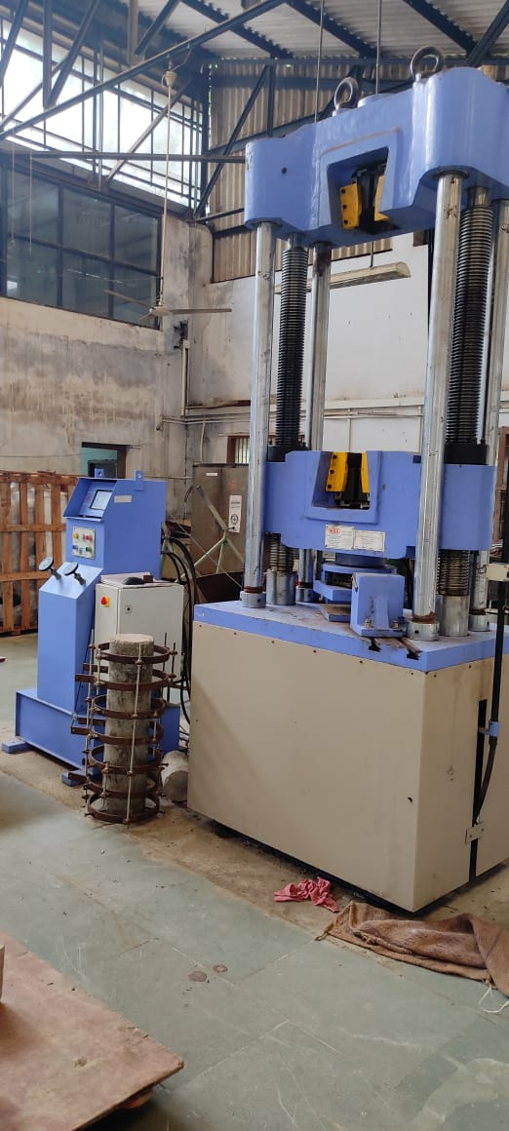
Universal Testing Machine

Automatic Compression Testing Machine along with Bending Testing Facility

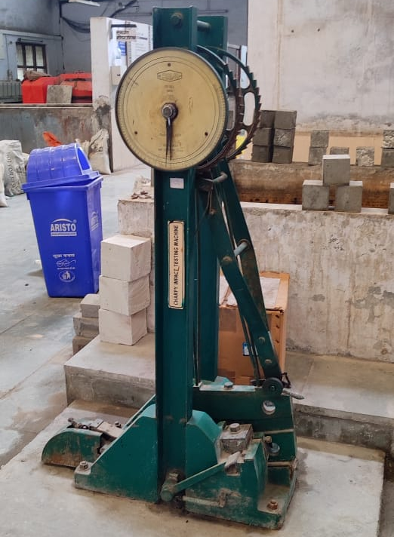
Charpy’s Impact Testing Machine

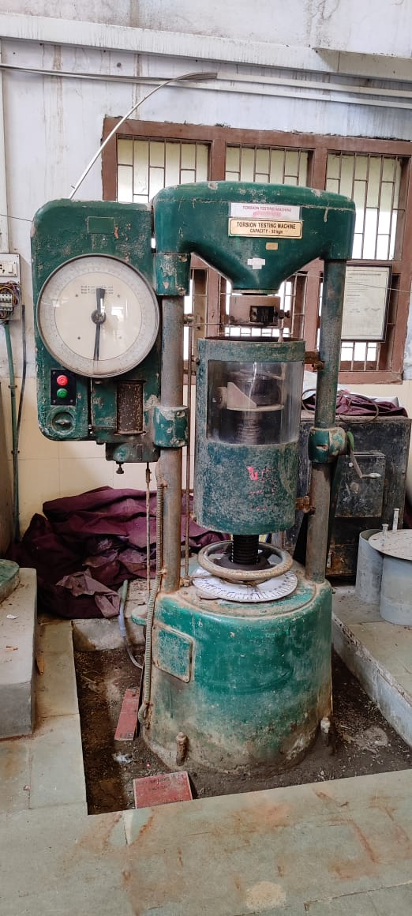
Torsion Testing Machine

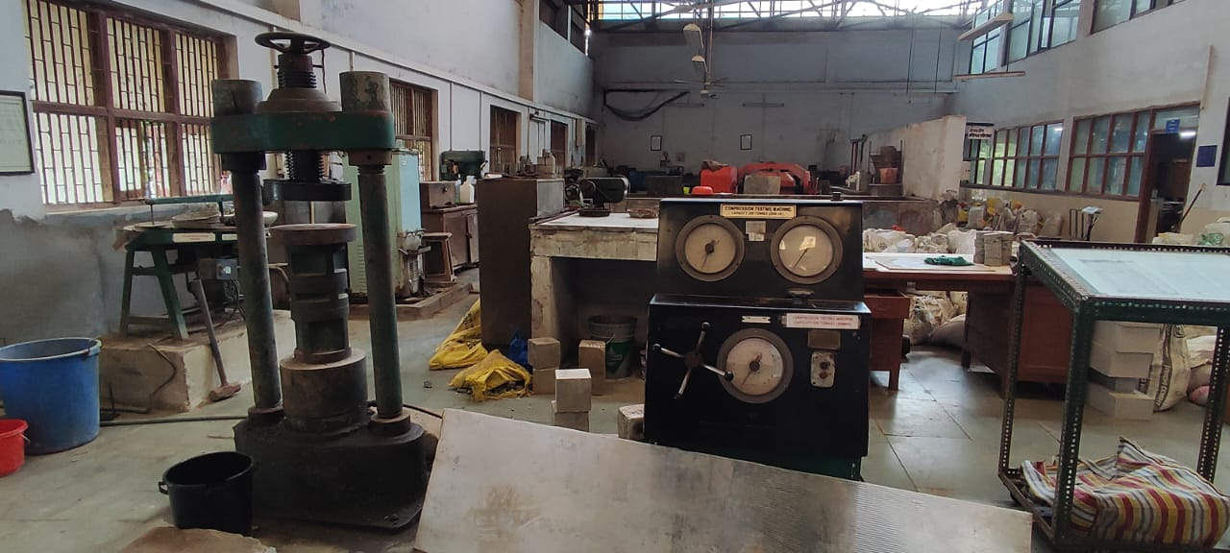
Compressive Testing Machine
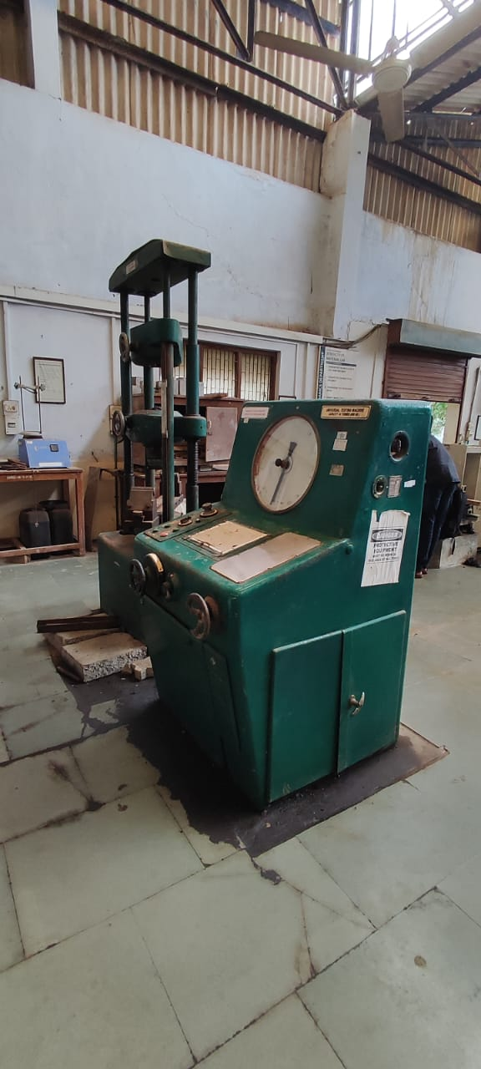
Universal Testing Machine (old)

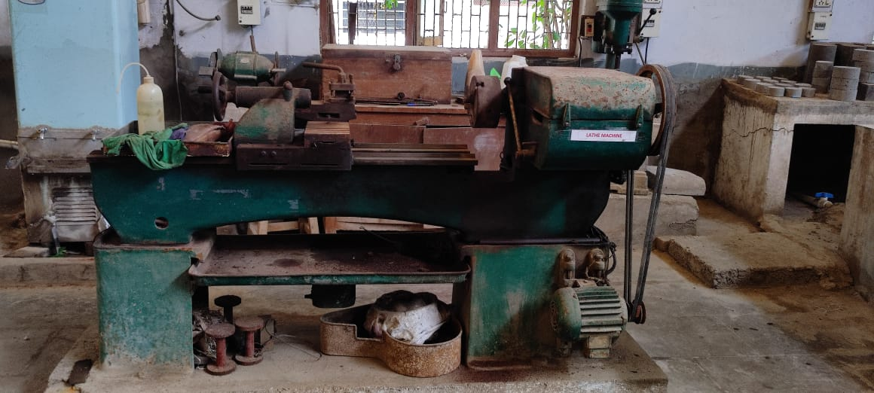
Lathe Machine

